**4、Dynamically Fused Graph Network for Multi-hop Reasoning（基于动态融合图网络的Multi-hop Reasoning）**

**ACL ’19**

**作者**：Yunxuan Xiao, Yanru Qu, Lin Qiu, Hao Zhou, Lei Li, Weinan Zhang, Yong Yu

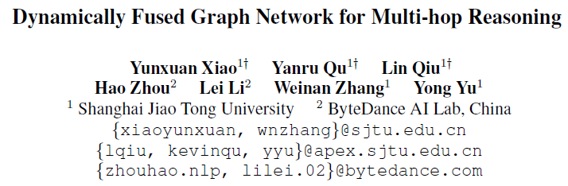

**摘要**：近年来，基于文本的问答(TBQA)得到了广泛的研究。大多数现有的方法侧重于在一段话内找到问题的答案。然而，许多有难度的问题需要来自两个或多个文档的分散文本的支持证据。**本文提出了**

**DFGN 动态融合图网络(Dynamically Fused Graph Network)，这是一种**

**解决需要多个分散证据和推理的问题的新方法。受人类逐步推理行为的启发，**

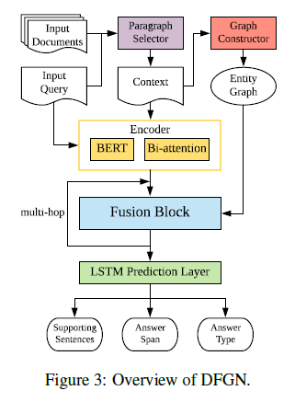

**DFGN包含一个动态融合层，从给定查询中提到的实体开始，**

**沿着文本动态构建的实体图进行探索（架构图 橘色），并**

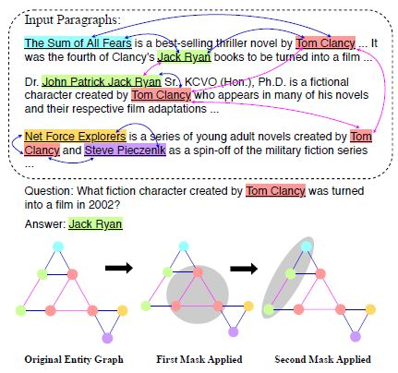

Figure 1: Example of multi-hop text-based QA. One question and three document paragraphs are given. Our proposed DFGN conducts multi-step reasoning over the facts by constructing an entity graph from multiple paragraphs, predicting a dynamic mask to select a subgraph, propagating information along the graph, and finally transfer the information from the graph back to the text in order to localize the answer.

Nodes are entity occurrences, with the

color denoting the underlying entity.

Edges are constructed from co-occurrences.

The gray circles are selected by DFGN in each step.

Fusion Block（架构图 兰块）

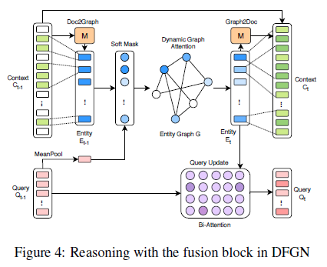

**逐步从给定文档中找到相关的支持实体**。

3.5 Prediction（基于LSTM， 架构图绿块）

We follow the same structure of prediction layers as (Yang et al., 2018). The framework has four output dimensions, including

1. supporting sentences,

2. the start position of the answer,

3. the end position of the answer, and

4. the answer type.

We use a cascade structure to solve the output dependency, where four isomorphic LSTMs Fi are stacked layer by layer. The context representation of the last fusion block is sent to the first LSTM F0. Each Fi outputs a logitO 2 RM_d2 and computes a cross entropy loss over these logits.

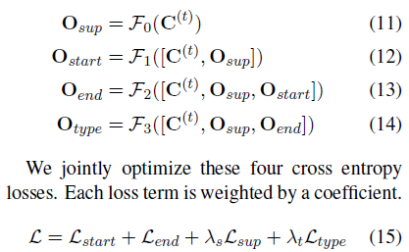

我们在需要multi-hop reasoning的公共TBQA数据集HotpotQA上评估了DFGN。DFGN在公共数据集上取得了有竞争力的成绩。此外，我们的分析表明，DFGN可以产生可解释的推理链。

**网址**：

https://arxiv.org/abs/1905.06933